- The Call of Andara’s Horn
- Mapline of the Hollow Sequence
- The Third Silence of Atraxus

The laser maze is named The Beamstream of Marglor the Unforgiving, or maybe there’s just a picture of Marglor
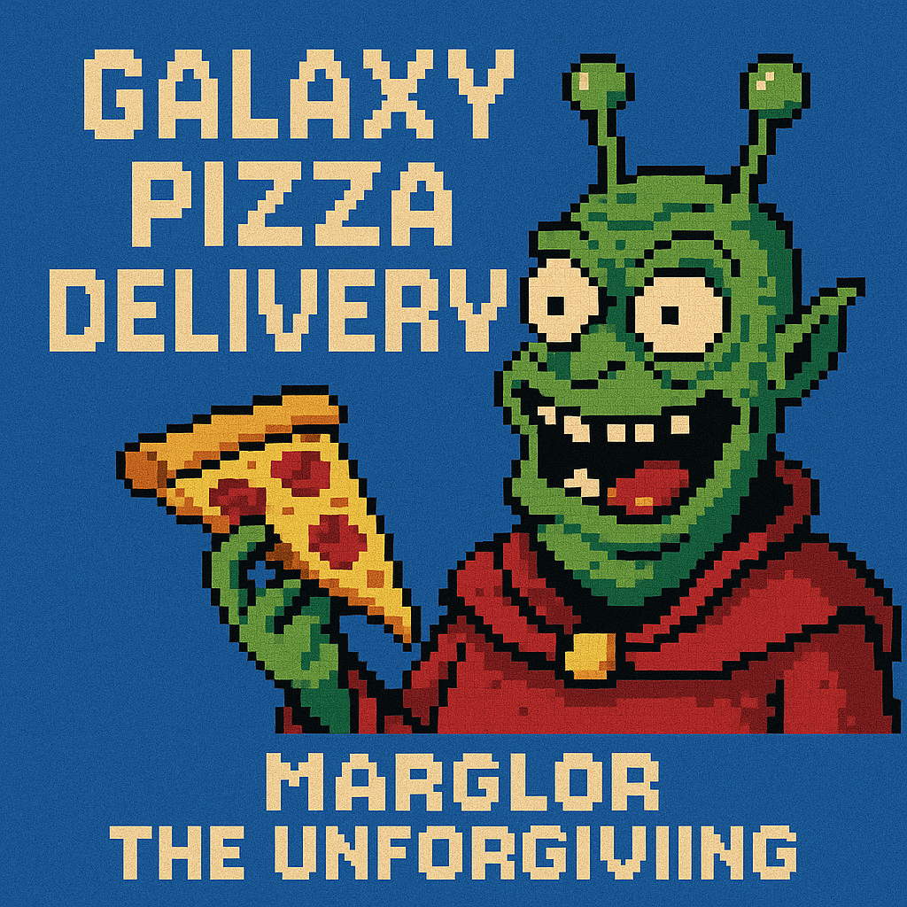

The picture of Marglor is on a wall somewhere. It’s framed and looks super old, and it’s surrounded by other pictures, advertisements, and announcements. Gavin only sees it because he recognizes Marglor, who is quite burned in his brain at this point, and it makes him feel ultra creepy to step inside.
Maybe Gavin hasn’t tried the laser maze in years because everyone knows it’s darn near impossible.
Also in the past in the book needs to establish the three runes you use. They need to have memorable names. Then Gavin needs to have that feeling he had when he defeated the beamstream in the game. They are The Call of Andara’s Horn. The Mapline of the Hollow Sequence. And The Third Silence of Atraxus.
Galaxy Pizza Delivery: The Beamstream of Marglor the Unforgiving
To deliver this pizza, you must pass through The Beamstream of Marglor the Unforgiving.
Choose your Beamstream
(then you get a slot machine with three wheels, each showing the range of alien runes)
Anything other than the one right code leads to a level that cannot be beat.
The right code leads to a healthy challenge but one that’s totally doable.
When you get to the end, the glyph of orion appears. The prize path at the end of the laser maze has stuff that lights up when lasers hit it and when Gavin selects the Glyph of Orion he gets….
Another puzzle box? No.
A key. Almost certainly
An Arduino? Yes
And Arduino and a key inside a Galaxy Pizza Delivery lunchbox.

